Results
Forest Plot and Pooled Estimates
Figure 2 presents study-specific and pooled protection percentages (PP%) against Aedes aegypti for nine synthetic-repellent and 21 natural-repellent studies, together with confidence intervals (CIs) and prediction intervals (PIs).
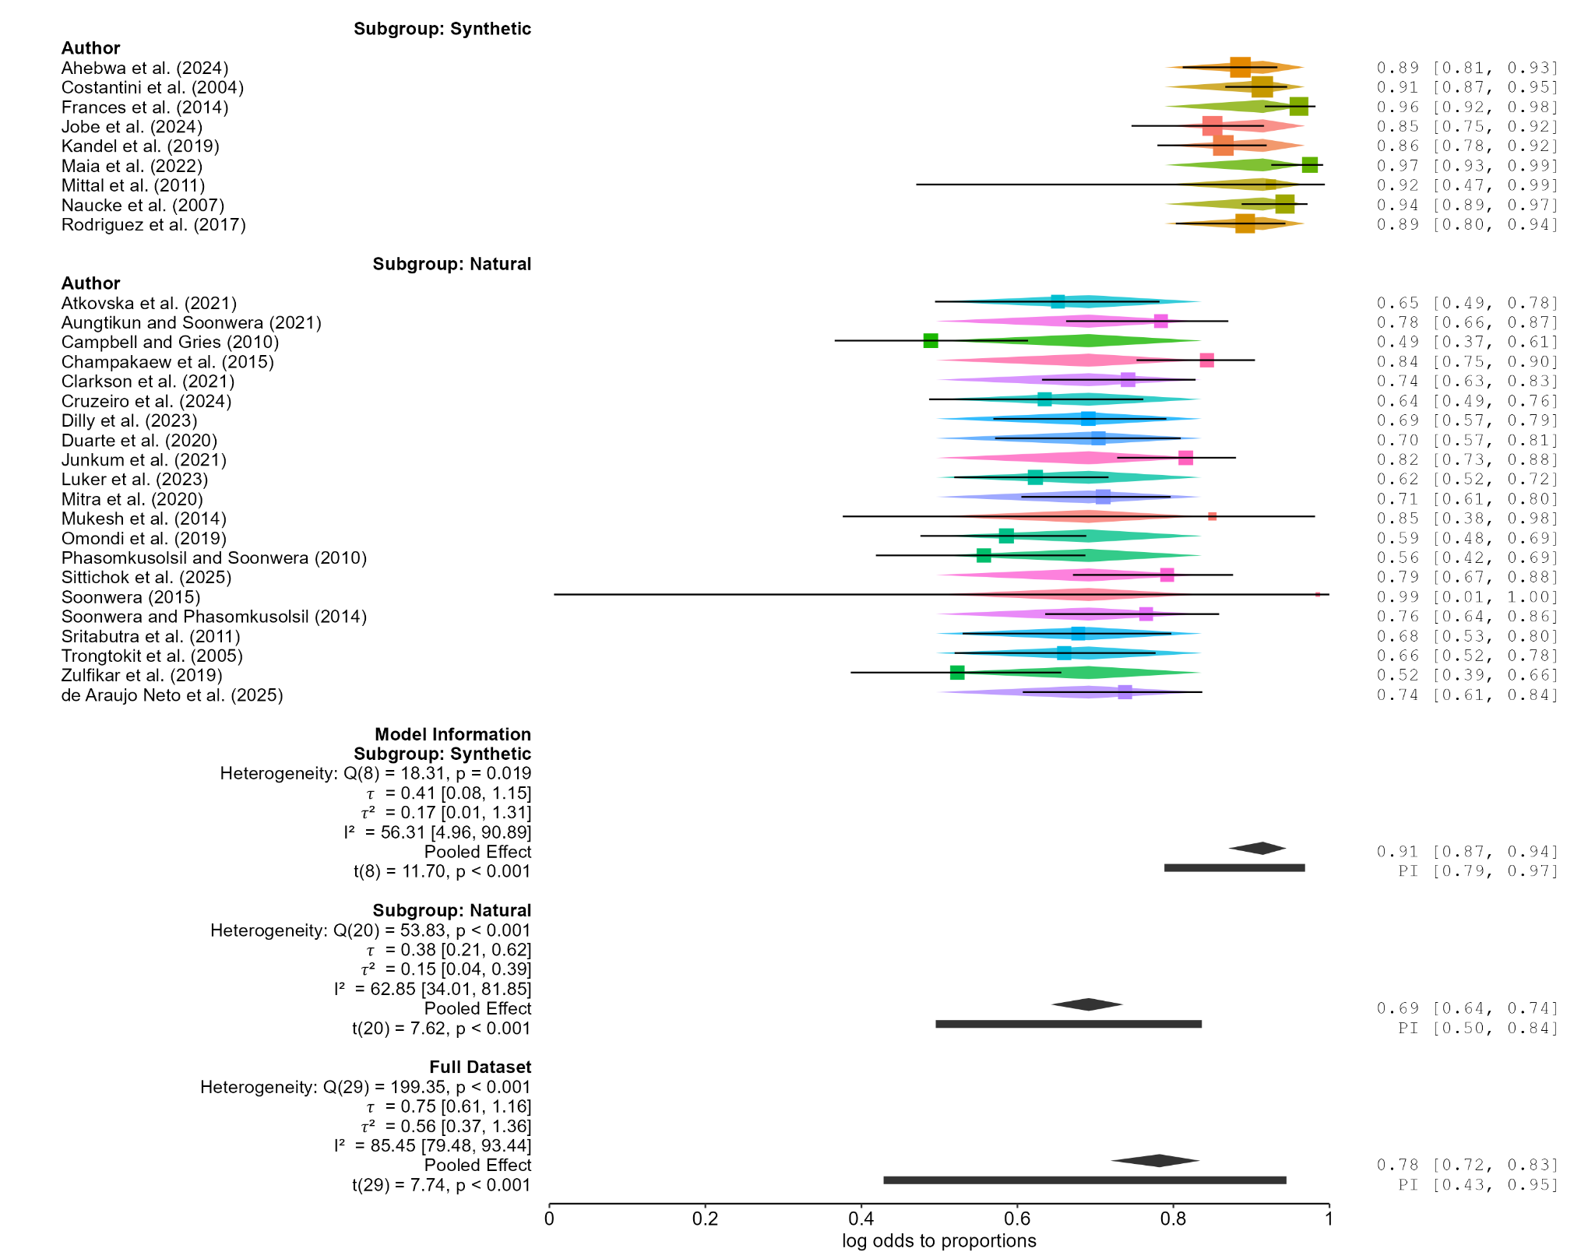
Figure 2. Forest plot of protection percentages for synthetic and natural repellents against Aedes aegypti. Horizontal lines indicate study-level 95% CIs; diamonds indicate pooled estimates and thick bars indicate 95% PIs.
Synthetic repellents had a pooled PP% of 91.5% (95% CI: 87.1-94.5%), compared with 69.1% (95% CI: 64.2-73.6%) for natural repellents. The subgroup-difference test was statistically significant (Q_M(1) = 46.86, p < 0.001), indicating higher pooled protection in the synthetic category. This is a between-study comparison, not a pooled head-to-head treatment effect. The overall estimate shown in the forest plot was approximately 78% (95% CI: 72-83%).
Heterogeneity was substantial within the synthetic (Q(8) = 18.31, p = 0.019; I² = 56.31%; tau² = 0.169) and natural (Q(20) = 53.83, p < 0.001; I² = 62.85%; tau² = 0.145) subgroups, and higher overall (I² = 85.45%). The 95% PIs were 78.8-96.9% for synthetic and 49.5-83.7% for natural repellents, indicating appreciable between-study variation, particularly in the natural category. These inferential results remain provisional because the input standard errors were approximated from PP% and heterogeneous sample-size definitions rather than verified outcome-specific variance estimates.
Publication Bias and Funnel Plots
Natural Repellents
Figure 3A displays the residual funnel plot for the 21 natural-repellent studies. Residual values are plotted against standard errors to examine the distribution of study estimates around the subgroup model.
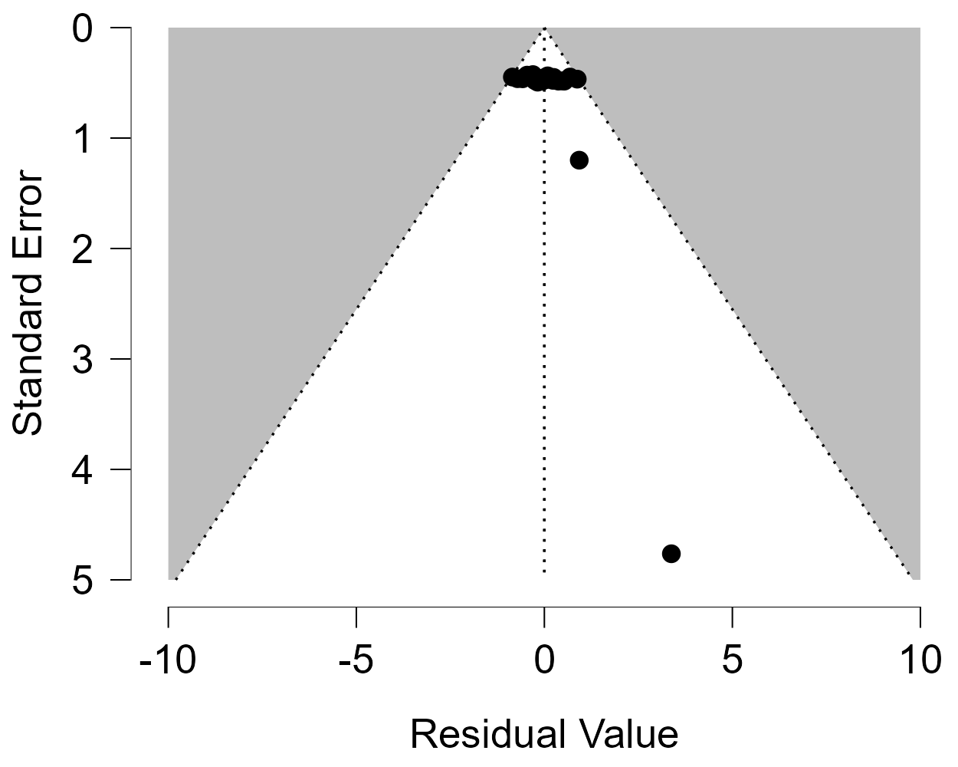
Figure 3A. Residual funnel plot for natural repellents against Aedes aegypti. The vertical dotted line marks zero residual; diagonal dotted lines delimit the displayed funnel.
Most study estimates cluster near the upper part of the plot, on both sides of the zero-residual line, indicating relatively greater precision than the two observations lower in the plot. Two positive-residual observations have markedly larger standard errors, approximately 1.2 and 4.8, and therefore provide much less precise estimates. The most imprecise observation is substantially displaced to the right of the central line. This pattern indicates uneven precision and a right-sided distribution among the least precise observations, although the dense upper cluster makes exact visual assessment of symmetry difficult.
The visible observations appear to lie within the displayed funnel boundaries; however, this does not establish the absence of publication bias. The residual plot alone cannot distinguish selective publication from heterogeneity or uncertainty in the standard-error inputs. No Egger regression-test table is included in the supplied JASP output, so no updated Egger p-value or formal conclusion about small-study effects can be reported. The subgroup includes 21 studies and therefore meets the manuscript's prespecified minimum of ten studies for considering that test, subject to validation of the underlying variance estimates.
Synthetic Repellents
Figure 3B presents the residual funnel plot for the nine synthetic-repellent studies. The distribution is examined visually to describe precision and possible imbalance around the subgroup model.
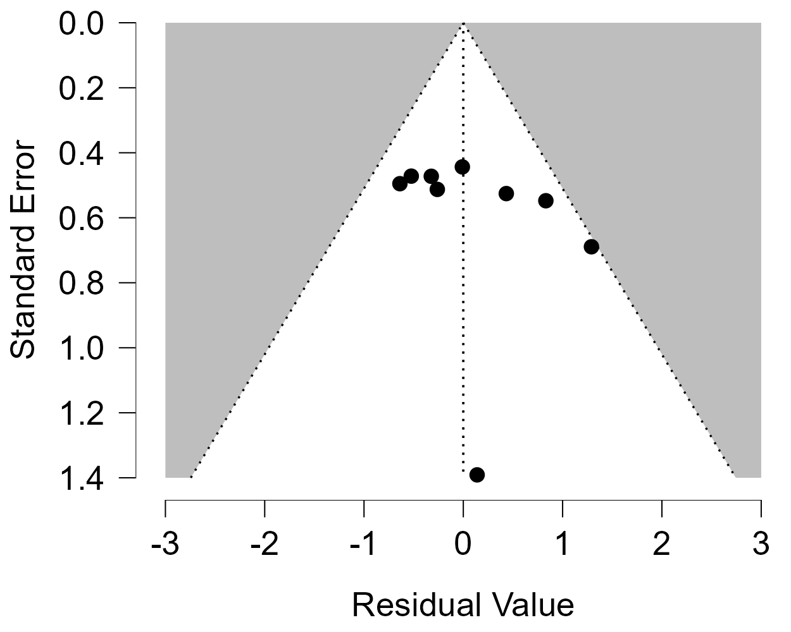
Figure 3B. Residual funnel plot for synthetic repellents against Aedes aegypti. The vertical dotted line marks zero residual; diagonal dotted lines delimit the displayed funnel.
Most observations occupy the upper portion of the funnel, with standard errors of approximately 0.44-0.69 and residual values on both sides of zero. One observation lies farther to the right, near the funnel boundary, whereas the least precise observation has a standard error of approximately 1.4 and a residual close to zero. The visible points appear to remain within the displayed funnel boundaries. There is no pronounced one-sided concentration across the entire plot, although the rightward observation indicates some imbalance among the more precise studies.
With only nine studies, the plot provides limited evidence for judging funnel symmetry, and an apparently balanced distribution cannot exclude publication bias. Under the manuscript's prespecified approach, Egger's regression test is not interpreted for this subgroup because fewer than ten studies are available. Accordingly, this finding should be reported as a cautious visual assessment, rather than evidence that publication bias is absent; its interpretation also remains conditional on the validity of the standard-error inputs.

